like / love / hate + verb + -ing: Activity 1
- meeting
- stopping
- buying
- going
- crying
- writing
- running
- bike riding
- getting
- driving
- sitting
- using
- putting
- finishing

like / love / hate + verb + -ing: Activity 2
- She likes cooking
- Do you like traveling
- I love shopping for presents
- They don't like watching TV
- Does your father like playing chess
- George doesn't like exercising
- My mother loves reading detective novels
- We don't like flying
Activities: Activity 1
- 
- 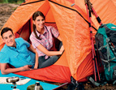
- 
- 
- 
- 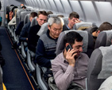
- 
- 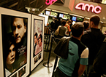
- 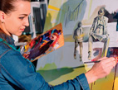
- 
- 
Activities: Activity 2
 |  |  | 
 | 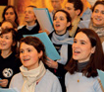 |  | 
 |  |  | 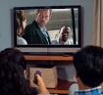
/ʊ/, /u/, and /ŋ/

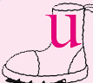
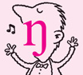
Carolina and Andre: Activity 1
- True
- False
- True
- False
- False
- False

Carolina and Andre: Activity 2
André Hi. Are you Carolina?
Carolina Yes. Are you André?
André Yes, I am.
Carolina Nice to meet you.
André You, too. Do you want a coffee?
Carolina No, thanks. I don’t like coffee . I prefer tea – green tea.
André Really? I love green tea . Um...two green teas, please. So, Carolina, what do you do?
Carolina I’m a student. I want to be a doctor.
André That’s interesting! I’m a nurse. I work at the hospital.
Carolina Really? Do you like working there?
André Yes, I do. I like it very much.
Carolina What about your free time? What do you like doing on the weekends, André?
André I love walking in the mountains. I go about twice a month.
Carolina Do you like camping ?
André Yes, I do. I always go camping in the summer. What about you?
Carolina I really like camping. And I love going for long walks. I study a lot during the week, so it’s good to be outside.
André Do you like cooking , Carolina?
Carolina Yes, I like cooking a lot. And I love eating !
André Me, too. What’s your favorite food?
Carolina I love all kinds of food. But I hate fast food .
André Me, too. It’s terrible. I really like Japanese food ...sushi, sashimi,...
Carolina I love sushi!
André Carolina, do you want to have dinner tonight?
Carolina Yes, why not?
André We can go for a walk and then go to my favorite Japanese restaurant.
Carolina I’d like that. Thanks, André.

