Superlative adjectives: Activity 1
- the biggest
- the best
- the most dangerous
- the hottest
- the youngest
- The most beautiful
- the worst
- the prettiest
Superlative adjectives: Activity 2
- Everest is the highest mountain in the world
- The Mona Lisa is the most famous painting in the world
- The Amazon is the longest river in South America
- The Louvre is the most popular museum in Europe
- Shanghai is the biggest city in China
- Switzerland is the most expensive country in Europe
- Antarctica is the driest place in the world
- Lake Victoria is the largest lake in Africa
Places and buildings: Activity 1
- 
- 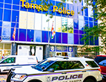
- 
- 
- 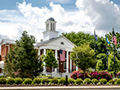
- 
- 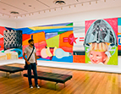
- 
- 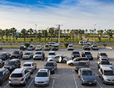
- 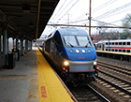

Places and buildings: Activity 2
 |  |  | 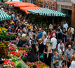
 |  |  | 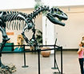
 | 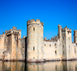 |  | 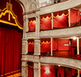

Food and drink: Activity 3
1. | a church | 5. | a river
2. | a park | 6. | a road
3. | a zoo | 7. | a square
4. | a bridge | 8. | a street

Consonant groups
1.the most expensive
2. the smallest
3.the most beautiful
4. the oldest
5. the most exciting
6. the fastest

Interview with a travel writer: Activity 1
1. | 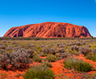
2. | 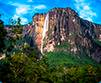
3. | 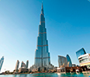
4. | 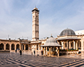
5. | 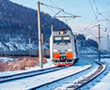
6. | 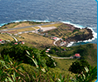
Interview with a travel writer: Activity 2
- largest
- highest
- 2,717
- 600
- longest
- 1,300

