Possessive adjectives: Activity 1
- your
- our
- He’s
- My
- she
- your
- We’re
- Its

Possessive adjectives: Activity 2
1. Her
2. Our
3. its
4. My
5. Their
6. your
7. His
8. your

Classroom language: Activity 1
- 
- 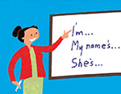
- 
- 
- 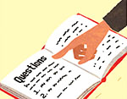
- 
- 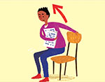
- 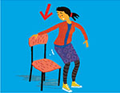
- 
- 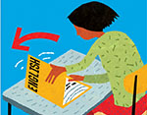
- 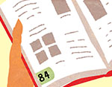
- 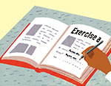

Classroom language: Activity 2

- Can I have a copy, please?
- How do you spell it?
- I don't know.
- How do you say gato in English?
- Can you help me, please?
- What page is it?
- Sorry, can you repeat that, please?
- Sorry I'm late.

The alphabet
- L
- J
- K
- C
- B
- M
- W
- Y
/oʊ/, /u/, /ɑr/
- /u/
- /ɑr/
- /oʊ/
- /u/
- /oʊ/
- /ɑr/
- /oʊ/
- /u/
- /ɑr/

Can I help you? Activity 1
- a hotel
- the US
- 503

Can I help you? Activity 2

First name Erik
Last name Taylor
Country USA
City Miami
Address 15 Atkinson Road
Zip code 33156
Email address eriktaylor @mail.com
Phone number 305-555- 5692 .
Cell phone number 305-555-5701

Writing 1 - Completing a form

VISIT AND SHORT STAY (VISAF2)
Visa application form for a visitor or student
About you
First name John
Last name (Family name) Evans
Mr / Mrs / Ms Mr
Date of birth 12 03 1987
Nationality American
Place of birth:
country US
town / city New York
Address
48 Main Street
Los Angeles
California
Email address john.evans@mail.com

