Singular and plural nouns: Activity 1
- They're photos
- They're watches
- They're cities
- They're addresses
- They're teachers
- They're universities
- They're change purses
- They're students

Singular and plural nouns: Activity 2
1. The children are at school.
2. One man is in a taxi.
3. The people are at the airport.
4. Two women are at the restaurant.
5. A person is in my hotel room.
6. Three men are in the museum.
7. A child is under the desk.
8. The woman is from Turkey.
Things: Activity 1
- 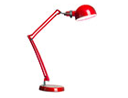
- 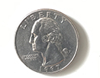
- 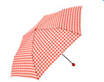
- 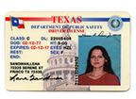
- 
- 
- 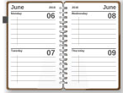
- 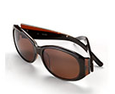
- 
- 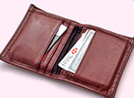
- 
- 
Things: Activity 2
1. | a tablet | 5. | a ticket
2. | a charger | 6. | a pen
3. | a notebook | 7. | a change purse
4. | a credit card | 8. | a key

Things: Activity 3
- in
- under
- on
- in
- on
- on
- under

What's in your bag? Activity 1
- Speaker 2
- Speaker 3

What's in your bag? Activity 2
- D
- B
- A
- C

