Prepositions - time
- on
- on
- at
- in
- on
- on
- in
- at
Prepositions - place

- in
- to
- at
- at
- to
- in
- to
- to
Daily routine: Activity 1
- take a shower
- have a coffee
- start work at 8:30
- get dressed
- wake up at 7:00
- put on make-up
- go to work by bus
- get to work

Daily routine: Activity 2

1. | check emails | 5. | go shopping
2. | do housework | 6. | go to bed
3. | finish work at 6.30 | 7. | have lunch at work
4. | get home late | 8. | have pizza for dinner

Daily routine: Activity 3
- 
- 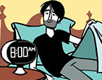
- 
- 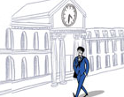
- 
- 
- 
- 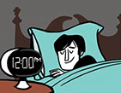
- 
- 
- 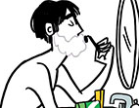
- 

Valeria's day: Activity 1
- an administrator
- on weekdays
- learns English
Valeria's day: Activity 2
Morning
She gets up at 6:00 .
She starts work at 9:00 .
Afternoon
She has coffee at 1:30 .
She finishes work at 5:30 and gets home around 6:00 .
Weekends
Valeria and her husband don't work on the weekends.
She usually gets up around 8:00 .
Her husband makes breakfast for the family.
She goes English class on Sunday at 4:00.
She goes to bed at 10:30 at night but doesn't go to sleep until about 11:00.

