be or do?: Activity 1
Are you...? | Do you...?
- cold  - bored  - frightened  - talking to me  - using the internet  - calling a taxi | - remember his name  - get up early  - walk to work  - have lunch at home  - wear glasses  - like animals
be or do?: Activity 2
1. A Does your parter cook?
B Yes. He 's making dinner now.
2. A Are you busy?
B Yes, I 'm doing my homework.
3. A How old is your father?
B He's 70, but he doesn't want to retire.
4. A Are you watching TV?
B No, we 're playing a video game.
5. A Do you speak German?
B Yes, but I don't speak it very well.
6. A Why are you crying?
B Because I 'm feeling sad.
Music: Activity 1
- 
- 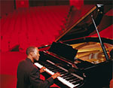
- 
- 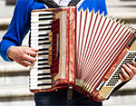
- 
- 
- 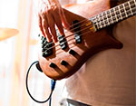
- 
- 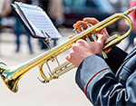

Music: Activity 2
1. pianist
2. trumpeter
3. keyboard player
4. violinist
5. bass player
6. guitarist
7. drummer
8. saxophonist
9. accordionist

/y/
1. you
2. yellow
3. music
4. young
5. year
6. beautiful

Music is changing their lives: Activity 1

- Venezuela
- money
- two
Music is changing their lives: Activity 2
1. conductor
2. project
3. classical music
4. dangerous
5. family
6. Los Angeles

