there is / there are
1. There's
2. Are there
3. There isn't
4. There are
5. Is there
6. There aren't
7. There's
8. Is there

some / any + plural nouns
A Tell me about your apartment, Danny.
B Oh, OK. Um, There's a living room...
A Are there any armchairs in the living room?
B No, but there's an orange sofa. I'm not sure if I like it, really.
A Hmm. What about the bedroom?
B The bedroom is very small. There's a bed, and there are some shelves for my books. But there isn't a closet.
A Oh. And the kitchen?
B It isn't very big. There aren't any cupboards, but there are some nice plants.
A Danny, why are you living there?
B Well, it's very cheap ...
The house - rooms
- a bedroom
- a living room
- a bathroom
- an office
- a hall
- a dining room
- a kitchen
The house - parts of a house
a balcony | a ceiling | a floor | stairs | a wall
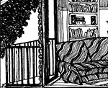 | 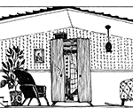 | 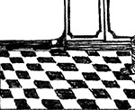 | 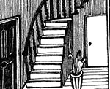 | 

The house - things in a room
- 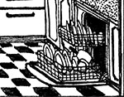
- 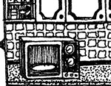
- 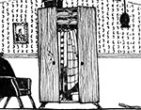
- 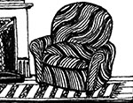
- 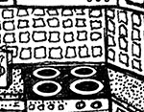
- 
- 
- 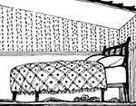
- 
- 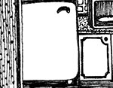
- 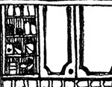
- 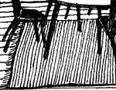

/ɛr/ and /ɪr/
- /ɛr/
- /ɛr/
- /ɪr/
- /ɛr/
- /ɪr/
- /ɪr/
- /ɛr/
- /ɪr/

This is the kitchen: Activity 1
- kitchen
- bathroom
- living room

This is the kitchen: Activity 2
- True
- False
- False
- True
- True
- False
- False
- True

