Quantifiers: Activity 1
- How much
- How much
- How many
- How much
- How many
- How many
- How much
- How many

Quantifiers: Activity 2
1. I don't put much salt on my food.
2. A How much chocolate do you eat?
B A little .
3. We don't eat lots of candy.
4. A How much fruit do you buy?
B A lot.
5. We eat a lot of fish.
6. A Do your children drink milk?
B No. Not much .
7. Donna ate her hamburger, but she didn't eat many French fries.
8. A How many vegetables do you eat?
B None . I don't like them.
9. I had a few cookies with my coffee.
10. A Do you eat much meat?
B No, I don't eat any meat. I'm a vegetarian.
Food containers: Activity 1
- 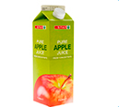
- 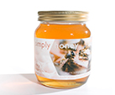
- 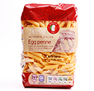
- 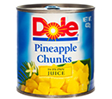
- 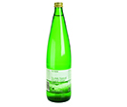
- 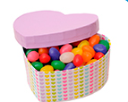
- 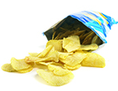

Food containers: Activity 2
- jar
- package
- can
- bottle
- box
- carton
- can

/ʃ/ and /s/
- /ʃ/
- /s/
- /s/
- /ʃ/
- /ʃ/
- /s/
- /ʃ/
- /s/

Healthy eating: Activity 1
- an expert on food
- five
- unhealthy
Healthy eating: Activity 2
- food
- rice
- fruit
- eggs
- cheese
- week

