Expressing movement: Activity 1
- to-into
- past
- along
- over
- towards
- over-into
- around
- across
Expressing movement: Activity 2
1. into
2. over
3. in
4. up
5. out
6. out of
7. away
8. down

Sports
play | go | do
baseball  basketball  soccer  handball  rugby  tennis  volleyball | cycling  skiing  windsurfing | track and field  gymnastics  karate  yoga

Expressing movement: Activity 1
 | under the bridge | 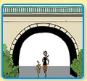
 | along the street | 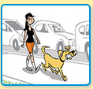
 | around the lake | 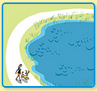
 | through the tunnel | 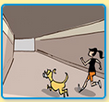
 | into the store | 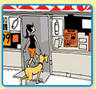
 | across the road | 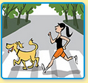

Expressing movement: Activity 2
- 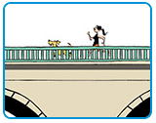
- 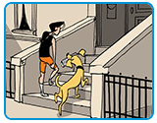
- 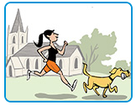
- 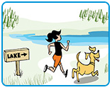
- 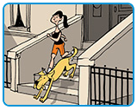
- 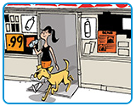

Word stress
- first
- first
- first
- first
- first
- second
- first
- second
- first
- first
- first
- first

Bad losers: Activity 1
- cards
- tennis
- ice hockey
- board games
- basketball

Bad losers: Activity 2
Speaker 1 : C
Speaker 2 : A
Speaker 3 : E
Speaker 4 : D
Speaker 5 : B

