Word order of phrasal verbs: Activity 1
- look after my little sister
- go out this evening
- both
- looking for a new job
- both
- try them on
- both
- get along with her
- take it back
- get up in the morning

Word order of phrasal verbs: Activity 2
- them up
- it on
- it up
- them out
- it back
- it on

Phrasal verbs: Activity 1
The game will  be over at  about 5:30. | My alarm goes off at six o'clock every morning. | We set off  for the airport  at 6:30. | I want to give up chocolate. | Don't throw away that letter! | Turn down the music! It's very loud.
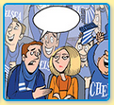 | 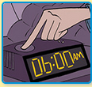 |  | 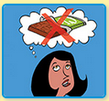 |  | 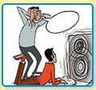

Phrasal verbs: Activity 2
- 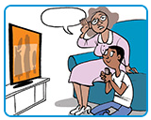
- 
- 
- 
- 
- 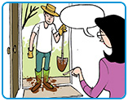
- 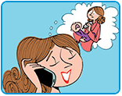
- 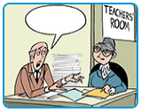

Linking
1. turn it off
2. pick it up
3. look it up
4. put it on
5. look after it
6. Take it off

Still tired in the morning? Activity 1
- Sleep at the same times
- Make sure you are exposed to light during the day
- Create a relaxing routine before going to bed
- Avoid stimulants
- Getting back to sleep

Still tired in the morning? Activity 2
- G
- B
- B
- B
- B
- B
- G
- B
- G
- G

