Present continuous: Activity 1
- It isn't snowing
- Oliver's wearing a suit today
- What book are you reading
- I'm planning a trip to the US
- You're standing on my foot
- They aren't getting along very well at the moment
- Is she wearing makeup
- I'm not sitting in my usual place today
Present continuous: Activity 2
1. My dog isn't dangerous. He doesn't bite .
2. Why are you wearing sunglasses? It 's raining !
3. You can turn off the radio. I 'm not listening to it.
4. I need to find an ATM.
5. A Do you usually cook on the weekends?
B No, we normally eat out.
6. Mario lives in Cancun, but he 's working in Mexico City at the moment.
7. I usually drink tea, but I want coffee today.
8. A What are you doing here?
B I 'm waiting for Emma. She's late, as usual.
Clothes: Activity 1
- 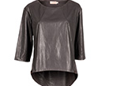
- 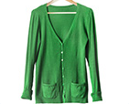
- 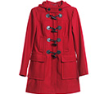
- 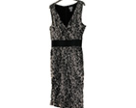
- 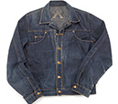
- 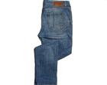
- 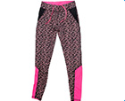
- 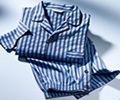
- 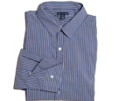
- 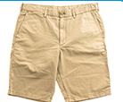
- 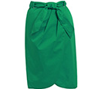
- 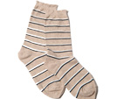
Clothes: Activity 2

1. | flip flops | 5. | tracksuit
2. | underwear | 6. | sandals
3. | pants | 7. | shoes
4. | T-shirt | 8. | boots
Clothes: Activity 3

- hat
- gloves
- scarf
- tie
- bracelet
- earrings
- necklace
- ring

Prepositions of place
- in
- in front of
- On
- between
- under
- Behind
- on the left of
- In the corner
- above
- next to

/ə/ and /ər/
- /ər/
- /ər/
- /ər/
- /ə/
- /ər/
- /ər/
- /ər/
- /ə/
- /ə/
- /ər/
- /ər/
Flower power: Activity 1
- an art exhibition
- makes pictures of flowers
- David Hockney

Flower power: Activity 2
- Paris
- Flowers
- bedroom
- sunrise
- January
- 5

