Present perfect + yet, already: Activity 1
- He hasn't cleaned the car yet
- She hasn't found a new job yet
- Have you spoken to Mr. Jackson
- We've booked a fantastic hotel
- They haven't finished eating yet
- Have you seen Paulo recently
- Has Amy done her homework
- We haven't replied to their email yet
Present perfect + yet, already: Activity 2
1. I've already had breakfast .
2. have you spoken to her yet ?
3. the movie has already started .
4. I haven't met his girlfriend yet .
5. they've already eaten dinner .
6. the manager has already gone home .
Housework: Activity 1
- 
- 
- 
- 
- 
- 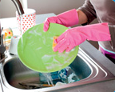
- 
- 

Housework: Activity 2
 |  |  | 
 |  |  | 
 | 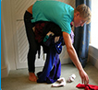 |  | 

make or do?

- do
- make
- do
- make
- make
- do
- make
- make

Sharing the housework: Activity 1
- a newspaper
- to give information
- Equality in the home
Sharing the housework: Activity 2
- True
- False
- True
- True
- False
- False
- True

