if + past, would + base form (Second conditional): Activity 1
- A
- E
- D
- C
- F
- G
- B
if + past, would + base form (Second conditional): Activity 2
- 'd get – had
- tried - 'd like
- wouldn't buy - didn't like
- 'd take - didn't have to
- rented – could
- 'd see – lived
- wouldn't go – were
- 'd learn – did
- 'd bike - wasn't
- wouldn't be – had to
Animals and insects: Activity 1

 | 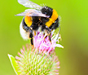 |  | 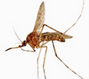
 |  |  | 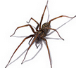
 | 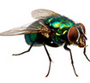 |  | 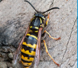

Animals and insects: Activity 2
- 
- 
- 
- 
- 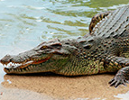
- 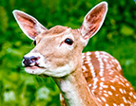
- 
- 
- 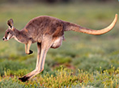
- 
- 
- 

Animals and insects: Activity 3
- rabbit
- rat
- snake
- tiger
- dolphin
- jellyfish
- shark
- whale
Word stress

- ca|mel
- cro|co|dile
- dol|phin
- e|le|phant
- gi|raffe
- kan|ga|roo
- li|on﻿
- mos|qui|to

Crocodile Attack! Activity 1
- there are lots of things you can do
- not to go near crocodiles
Crocodile Attack! Activity 2
- False
- True
- False
- True
- False
- True

