Modals of deduction: Activity 1
Read Grammar Bank 6B. Match sentences 1–10 to sentences A–J. Listen and check.
Grammar Bank
6B modals of deduction: might, can't, must
might (when you think something is possibly true)
EXAMPLES
Tony’s phone is turned off. He might be on the plane now, or just boarding.
Laura might not like that skirt. It’s not really her style.
can’t (when you are sure something is impossible / not true)
EXAMPLES
Brandon can’t earn much money at his job. He’s still living with his parents.
That woman can’t be Jack’s wife. Jack’s wife has dark hair.
must (when you are sure something is true)
EXAMPLES
The neighbors must be out. There aren’t any lights on in the house.
Your sister must have a lot of money if she drives a Porsche.
FORM
• We often use might, can’t, or must to say how sure or certain we are about something (based on the information we have).
• In this context, the opposite of must is can’t. Compare:
The neighbors must be out. There aren’t any lights on in the house.
The neighbors can’t be out. All the lights are on in the house. NOT The neighbors mustn’t be out.
• We can use may instead of might and we can use could in positive sentences.
Jack could (or may) be at the party – I’m not sure.
• We don’t use can instead of might / may. NOT He can be on the plane now.
• We often use be + gerund after might / must / can’t.
They must be having a party – the music’s very loud.

1 He might be American. ___
2 He can’t be a college student. ___
3 He must be cold. ___
4 He might be going to the gym. ___
5 He could be lost. ___
6 He must be married. ___
7 He must be a tourist. ___
8 He can’t be enjoying the party. ___
9 He may not have a job. ___
10 He can’t be a businessman. ___
A He’s carrying a sports bag.
B He’s carrying a camera and a guide book.
C He’s looking at a map.
D He’s wearing a baseball cap.
E He’s looking at job ads online.
F He isn’t talking to anybody.
G He isn’t wearing a suit.
H He’s wearing a wedding ring.
I He’s not old enough.
J It’s freezing and he isn’t wearing a jacket.

Modals of deduction: Activity 2
Complete the sentences with must, might (not), or can't. Listen and check.
1. A Do you know anyone who drives a Ferrari?
B Yes, my nephew. I don’t know his salary, but he _________ earn a fortune!
2. A Why don’t you buy this dress for your mom?
B I’m not sure. She _________ like it. It’s a little short for her.
3. A My sister works as an interpreter for the United Nations.
B She _________ speak a lot of languages to work there.
4. A Did you know that Andy’s parents have split up?
B Poor Andy. He _________ be very happy about that.
5. A Are your neighbors away? All the curtains are closed.
B I’m not sure. I suppose they _________ be on vacation.
6. A Where’s your colleague today?
B She _________ be sick. She called to say that she was going to the doctor’s.
7. A Jane’s looking at you in a very strange way.
B Yes. I’ve grown a beard since I saw her last, so she _________ recognize me.
8. A My daughter has failed all her exams again.
B She _________ be working very hard if she gets such bad grades.
9. A Why is Tina so happy?
B I’m not sure, but she _________ have a new partner.
10. A Where does your boss live?
B I don’t know, but he _________ live near the office because he commutes every day by train.

The body: Activity 1
Choose the words that match the definitions. Listen and check.
1. mouth
- 
- 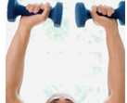
- 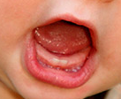
2. head
- 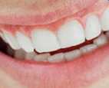
- 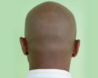
- 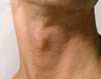
3. toes
- 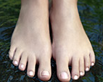
- 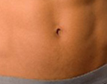
- 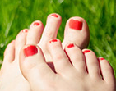
4. neck
- 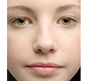
5. hands
- 
6. arms
7. feet
8. back
9. face
10. stomach
11. teeth

The body: Activity 2
Match the pictures to the correct words. Listen and check.
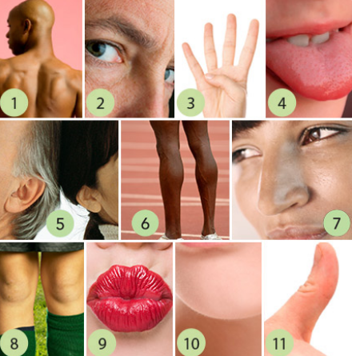
1.
  - chin
  - nose
  - shoulders
2.
  - legs
  - thumb
  - eyes
3.
  - lips
  - fingers
  - knees
4.
  - shoulders
  - thumb
  - tongue
5.
  - ears
  - lips
  - eyes
6.
  - chin
  - legs
  - fingers
7.
  - nose
  - tongue
  - shoulders
8.
  - eyes
  - knees
  - ears
9.
  - fingers
  - tongue
  - lips
10.
  - ears
  - chin
  - nose
11.
  - legs
  - knees
  - thumb
The body: Activity 3
Complete the sentences with a verb from the list in the correct tense. Listen and check.
bite clap kick nod point smell smile stare taste touch whistle
1. Don’t be frightened of the dog. He won’t _________ .
2. Jason _________ the ball too hard and it went over the wall into the next yard.
3. Mmm! Something _________ delicious! Are you making a cake?
4. The stranger _________ at me for a long time, but he didn’t say anything.
5. Can you _________ the sauce? I’m not sure if it needs more salt.
6. My dog always comes back when I _________ .
7. Don’t _________ the oven door! It’s really hot.
8. The audience _________ when I finished singing.
9. The teacher suddenly _________ at me and said, "What’s the answer?" I hadn’t even heard the question!
10. He's a very serious person – he never _________ .
11. Everybody _________ in agreement when I explained my idea.
Diphthongs
Listen and write the words in the list next to the correct sounds. Practice sayings the words in the sound groups.
face smile eyes mouth taste
outgoing bite nose shoulders
pointy throw voice toes
1. /aɪ/ bike
_______ _______ _______
2. /eɪ/ train
_______ _______
3. /oʊ/ phone
_______ _______ _______ _______
4. /aʊ/ owl
_______ _______
5. /ɔɪ/ boy
_______ _______

Photoshopping: Activity 1
Read and listen to the article. Choose the correct answers.
Photoshopping: how much is too much?
Today, it is normal for magazines to show pictures of models and celebrities that have been "photoshopped". This means that the original photos have been changed on a computer using photoshop software to make them look better. The beautiful people in the photographs have perfect skin, no fat on their stomachs, and no wrinkles on their faces. They look so perfect and beautiful that what we see can’t be real. But some publishers and advertisers insist that photoshopping is necessary so that celebrities and models always look their best.
On the other hand, health organizations have warned that digitally altering photographs may be dangerous. They say photoshopped images are not realistic, and may have a negative effect on people. Psychologists agree with the health organizations. They say some people try so hard to look like the pictures in magazines that they get sick. In some cases, they want to be as thin as the models and so they stop eating properly. When they realize that it is impossible to look so good, they get depressed. This can happen to people of all ages. So what can be done to keep everybody happy? Two researchers at Dartmouth University in New Hampshire think they have found the answer.
Professor Hany Farid and Doctor Eric Kee have developed a computer program that can detect how much photoshopping has been used on an image. Their software gives a rating from 1 to 5 to the image — 1 for a few changes, and 5 for a lot of changes. Farid and Kee’s idea is that publishers include the rating next to the image. That way, consumers will be able to work out how realistic the image is.
News of Farid and Kee’s system has come out at the same time as people have started criticizing the use of photoshopping. They say that some advertisers are going too far with it. The actress Rachel Weisz appeared in an ad for an anti-ageing beauty cream. In the ad, Ms. Weisz looked like a teenager — in fact, she's in her early forties. There were a lot of complaints about the image and the ad was eventually banned in the UK. Farid and Kee’s system could solve two problems at the same time. First, it would serve as a kind of health warning for consumers, and second it may stop advertisers from relying on photoshopping so much.

- Who is concerned about photoshopping?
  - advertisers
  - health organizations
  - celebrities
- What is the writer's opinion of photoshopping?
  - Publishers should be able to use it a little.
  - Publishers shouldn’t be able to use it at all.
  - Publishers should be able to use it as much as they want to.

Photoshopping: Activity 2
Read the article again and choose the best answers. Then look at the underlined words and phrases. What do you think they mean?
Photoshopping: how much is too much?
Today, it is normal for magazines to show pictures of models and celebrities that have been "photoshopped". This means that the original photos have been changed on a computer using photoshop software to make them look better. The beautiful people in the photographs have perfect skin, no fat on their stomachs, and no wrinkles on their faces. They look so perfect and beautiful that what we see can’t be real. But some publishers and advertisers insist that photoshopping is necessary so that celebrities and models always look their best.
On the other hand, health organizations have warned that digitally altering photographs may be dangerous. They say photoshopped images are not realistic, and may have a negative effect on people. Psychologists agree with the health organizations. They say some people try so hard to look like the pictures in magazines that they get sick. In some cases, they want to be as thin as the models and so they stop eating properly. When they realize that it is impossible to look so good, they get depressed. This can happen to people of all ages. So what can be done to keep everybody happy? Two researchers at Dartmouth University in New Hampshire think they have found the answer.
Professor Hany Farid and Doctor Eric Kee have developed a computer program that can detect how much photoshopping has been used on an image. Their software gives a rating from 1 to 5 to the image — 1 for a few changes, and 5 for a lot of changes. Farid and Klee’s idea is that publishers include the rating next to the image. That way, consumers will be able to figure out how realistic the image is.
News of Farid and Kee’s system has come out at the same time as people have started criticizing the use of photoshopping. They say that some advertisers are going too far with it. The actress Rachel Weisz appeared in an ad for an anti-ageing beauty cream. In the ad, Ms. Weisz looked like a teenager — in fact, she's in her early forties. There were a lot of complaints about the image and the ad was eventually banned in the UK. Farid and Kee’s system could solve two problems at the same time. First, it would serve as a kind of health warning for consumers, and second it may stop advertisers from relying on photoshopping so much.
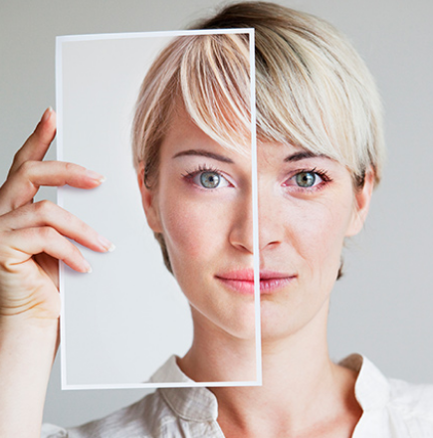
- According to the article, publishers use photoshopping to make people look ______.
  - as young as possible
  - as good as possible
  - as thin as possible
- ______ can be badly affected by photoshopped images.
  - Girls of all ages
  - Young teenagers
  - All kinds of people
- The new program gives a rating of 1 to an image with ______.
  - a little photoshopping
  - no photoshopping
  - a lot of photoshopping
- People complained about the Rachel Weisz ad because ______.
  - it showed the actress as she really was
  - it used an image of a different actress
  - it made her look younger than she was
- The people who will benefit most from the new tool are _____.
  - advertisers
  - consumers
  - publishers

