Modals of deduction: Activity 1
- D
- I
- J
- A
- C
- H
- B
- F
- E
- G

Modals of deduction: Activity 2
- must
- might not
- must
- can't
- might
- must
- might not
- can't
- might
- can't
The body: Activity 1
- 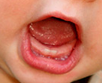
- 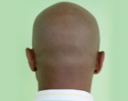
- 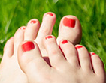
- 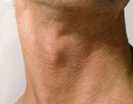
- 
- 
- 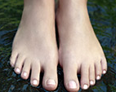
- 
- 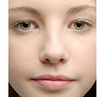
- 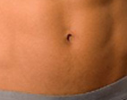
- 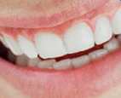
The body: Activity 2
- shoulders
- eyes
- fingers
- tongue
- ears
- legs
- nose
- knees
- lips
- chin
- thumb
The body: Activity 3
- bite
- kicked
- smells
- stared
- taste
- whistle
- touch
- clapped
- pointed
- smiles
- nodded
Diphthongs
- bite eyes smile
- face taste
- nose shoulders toes throw
- mouth outgoing
- pointy voice
Photoshopping: Activity 1
- health organizations
- Publishers should be able to use it a little.
Photoshopping: Activity 2
- as good as possible
- All kinds of people
- it made her look younger than she was
- consumers

