Using adjectives as nouns, adjective order: Activity 1
- The Vietnamese
- The Dutch
- the sick
- the blind
- The Chinese
- the injured
- the homeless
- the unemployed
- the dead
- the deaf
Using adjectives as nouns, adjective order: Activity 2
- an attractive young
- dirty old
- a beautiful black velvet
- a tall teenage American
- a long sandy
- a magnificent 17th century country
- a stylish Italian leather
- huge dark
- a friendly old black
- a striped cotton
Clothes and fashion: Activity 1
- 
- 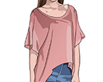
- 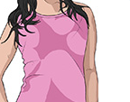
- 
- 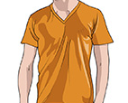
- 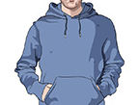
- 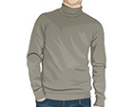
- 
- 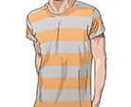
- 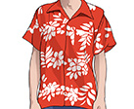
- 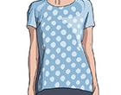
- 
Clothes and fashion: Activity 2

1. a cotton undershirt

2. a denim vest

3. a fur collar

4. a lace top

5. a linen suit

6. a lycra swimsuit

7. a silk scarf

8. a velvet bow tie

9. a wool cardigan

10. leather sandals

11. suede boots
Clothes and fashion: Activity 3
- casual
- scruffy
- fashionable
- old-fashioned
- classic

Clothes and fashion: Activity 4
- C
- A
- F
- H
- G
- B
- E
- I
- D
Vowel sounds

- tie
- striped
- slippers
- shoes
- skirt
Getting older: Activity 1
- being alone
- health
- mood
- resources
- retirement
Getting older: Activity 2
- False
- False
- True
- False
- False

